Safeguarding Page
Our clubs are committed to good practice in which we protect children and vulnerable adults from harm. Our staff and volunteers accept and recognise their responsibility to provide an environment which promotes a safe and secure environment for all participants at all times.
As part of this process we want to ensure that some of our policies, procedures and codes of conduct are available to our members by having them available online. As well as having essential contact information freely available.

Our lead Safeguarding / Welfare Officer is <Your Name>
Your Photo

Contact Telephone
Contact Email
Should we need to escalate a case, we will contact our national governing body (the British Tae Kwon-Do Council). Their Safeguarding / Welfare Officers information can be found at www.tkdcouncil.com/safeguarding

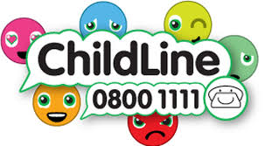

As part of our commitment, the following documents and policies are available to download:
Guidelines for Dealing with an Accident
Child Protection Policy
Sports Equity Policy
Code of Conduct for Parents / Carers
Code of Conduct for Students
Code of Conduct for Spectators
Code of Conduct for Instructors
Code of Conduct for Officials
Code of Conduct for Volunteers

